Cybersecurity Dataset Analysis
Sabrina Barrile Robert Quaye
1. Motivation
Cybersecurity is becoming an increasingly important as organizations face rising threats from various cyberattacks. This not only applies to organizations, though, as cybersecurity affects the majority of our population in their everyday lives. Whether it is IoT device protection, physical security, or safeguarding personal information, cybersecurity plays a crucial role in ensuring the safety and privacy of individuals. The interconnected nature of our digital world means that vulnerabilities in one system can have enormous effects, impacting millions. Effective response actions to these attacks are critical in preventing data breaches and minimizing damage. In particular, the ability to predict the appropriate response action based on the type and severity of an attack can greatly improve automated systems, making them more efficient and reducing human error. By leveraging a dataset containing different attack types, severities, and corresponding response actions, we aim to build a model that can predict the most effective response in real-time, helping organizations better defend against cyber threats.
2. Datasets
For our data set and research database, we utilized open-source data, “AI-Enhanced Cybersecurity Events Dataset” from Kaggle.
2.1 Dataset description
The dataset we retrieved from Kaggle contains 10 columns and 20,000 rows. The columns are Event ID, Timestamp, Source IP, Destination IP, User Agent, Attack Type, Data Exfiltrated, Threat Intelligence, and Response Action. The source data was also presented in a CSV format allowing for easy data manipulation and extraction.
2.2 Data Preparation
To properly and effectively use the data we had to undergo certain data preparations and cleaning techniques. To begin the preparation of our data, we first checked to see if there were any null or missing data. Per the results of the search, we came to a conclusion that there were none, so we continued on with the dataset. Afterwards, we devised a strategy to determine what columns we needed per the model and research question we were undertaking. We kept only the Attack Type, Attack Severity, Response Action, and Data Exfiltrated columns. We also made the decision to reduce the size of the dataset to a sample of about 1000 entries, to make sample data easier to work with and also to compare results to the population. We also had to change the format of the Attack Type, Attack Severity, and Response action from string to float, then convert the columns into integer type to allow better integration with the supervised models. We used OrdinalEncoder to transform both Attack Severity and Response Action to numerical format. We then used get_dummies function to transform the Attack Types to numerical format for easier data processing and manipulation.
3.1 Research Questions
For our main research question, we looked at predicting based on the Attack Severity, Attack Type, and Data Exfiltrated what is the most appropriate Response Action. We also developed visualization features to come up with what are the most common types of attacks (Malware, Ransomware, DDoS, Insider Threat, and Phishing) carried out in cyber attacks and what is the commonality of it being either a severe or critical attack.
4. Research Method
Our research focused on analyzing various cybersecurity attacks to understand their impacts and evaluate the potential for predicting future attacks to enhance prevention efforts. First, we decided on a dataset that interested both of us and aligned with our experience with real-world security work. Having this background helped us identify what cybersecurity professionals would likely be looking for and we decided to base our questions around that. Once we found a dataset we deemed suitable that was presenting cyberattacks, we proceeded with the data preparation. We reduced its size, checked for any missing values, and removed any columns we deemed unnecessary for our research questions.
We then began to experiment with multiple supervised learning models, to decide what fit best for each question. Ultimately, we decided on a count plot graph, trendline graph, Decision Tree Model, and K-Nearest Neighbor Model. To answer our first research question, What’s the most common attack type/severity? we used a count plot graph. This graph provided the clearest comparison of attack types by visually highlighting the differences. For our second question, What’s the trend in attacks per month? we decided to use a trendline graph. We decided on data between the years 2020 and 2024, a span of about 4 years, so the line graph made it easy to see how frequently the number of attacks fluctuated.
For our last question, Can we predict the likelihood of a response action per attack severity/type?, we decided to use the supervised learning models, K-Nearest Neighbor (KNN), and Decision Tree. However, the KNN and Decision Tree models gave us a bit of trouble. We used OneHotEncoder to change our data from a qualitative format to a quantitative one. This format was most suitable for our models. Both percentages, though, were far lower than anticipated. To address this problem, we decided to reduce the amount in the dataset and see what changes could occur. These newer results did not make that great of a difference and only emphasized how complex it is to make precise predictions in cybersecurity scenarios.
5. Findings and Results
Based on our models we came to a conclusion that the most appropriate response action to a cyberattack can never be entirely predicted or decided based on the attack type (i.e. Ransomware, DDoS, Insider Threat, Malware, Phishing) and the severity of the attack. Based on our results when we developed our first model which was the Decision Tree Model, we used the various attack types (Ransomware, DDoS, Insider Threat, Malware, Phishing) as well as the different attack severity levels (i.e. Low, Meduim, High, Critical ) and whether or not Data was exfiltrated meaning whether or not the attacks were able to gather information from the systems, we had an accuracy score of 25.2% in predicting the response action.
In hindsight of this we decided on developing a second model to compare results. We developed a K-Nearest Neighbor model to analyse and predict the data. Using the same variables, the various attack types (Ransomware, DDoS, Insider Threat, Malware, Phishing) as well as the different attack severity levels (i.e. Low, Meduim, High, Critical ) and whether or not Data was exfiltrated meaning whether or not the attacks were able to gather information from the systems, we had a similar accuracy of 25.6%.
Following this we decided on working with a reduced dataset of a 1000 random samples from the initial dataset. We used a Decision Tree Model for this and ended up with a testing accuracy of 23.7%, a figure lower than our previous models and larger datasets. We then finally decided on running the dataset through a LLM specifically ChatGPT to see what was it believed was the best model and parameters to run the dataset on and what will its accuracy be.The model ended up with an accuracy of 24.2%.
Per the consistency in results, we came up with our conclusion that response actions will vary depending on the infrastructure and the cybersecurity team of the organization. There is no exact rule to follow when dealing with attacks and the best solutions are relative to whoever picks them.

- What was the common common attack severity?
  - 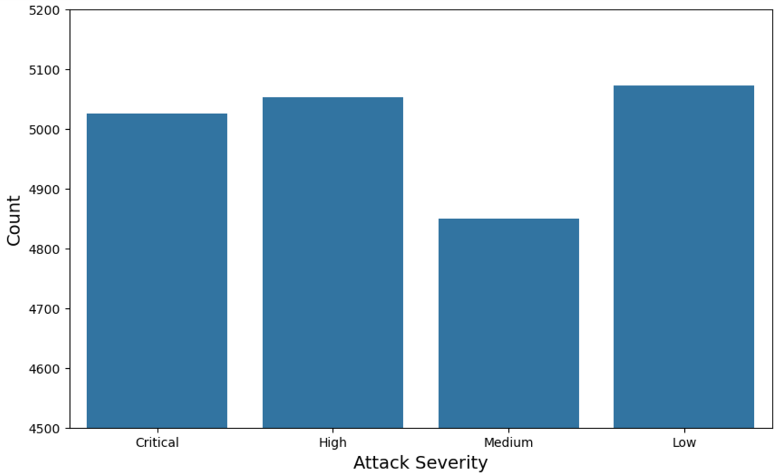
  - From the results of the graph, we were able to determine that the most frequent level of attack severity (Low, Meduim, High, Critical) was a Low level, closely followed by High Severity attacks, then Critical attacks. There was a substantial difference between the highest frequency and lowest frequency of about nearly 500 counts. The lowest frequency of attack severity was medium.

- What was the common common attack type?
  - 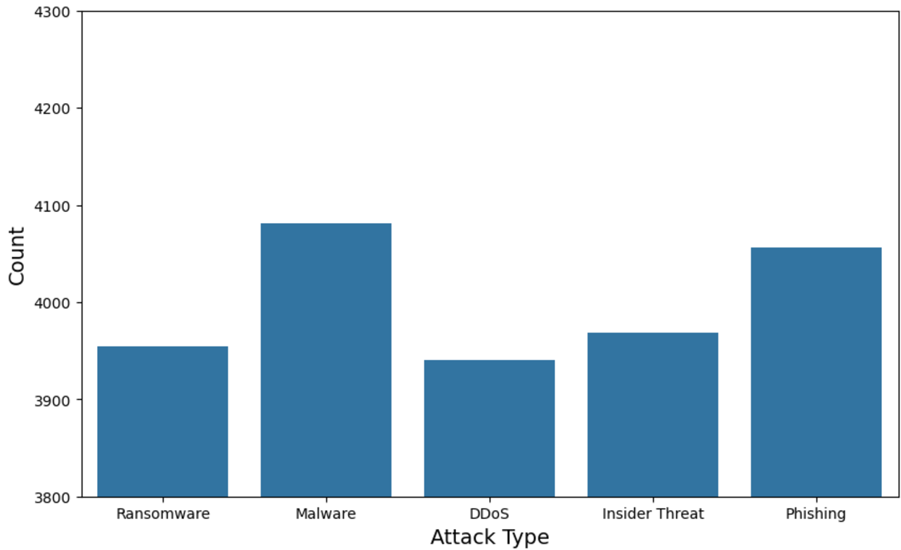
  - From the results of the graph, we were able to determine that the most frequent level of Attack Type (Ransomware, DDoS, Insider Threat, Malware, Phishing) was Malware, closely followed by Phishing attacks, third Insider Threat attacks and Ransomware. There was a substantial difference between the highest frequency and lowest frequency of about nearly 200 counts. The lowest frequency of attack type was DDoS attacks.

- What was the frequency of the different Response Actions?
  - 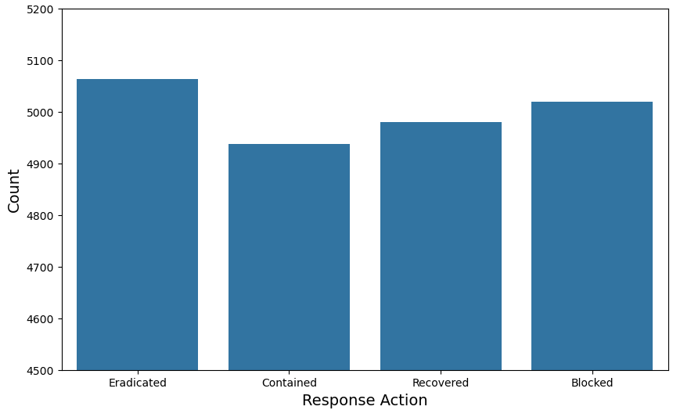
  - From the results of the graph, we were able to determine that the most frequent response action (Eradicated, Contained, Recovered, Blocked) was Eridacted, closely followed by Blocked, third was Recovered. There was not so much substantial difference between the highest frequency and lowest frequency. The lowest frequency of response action was Contained.

- What was the trend in attacks per month?
  - 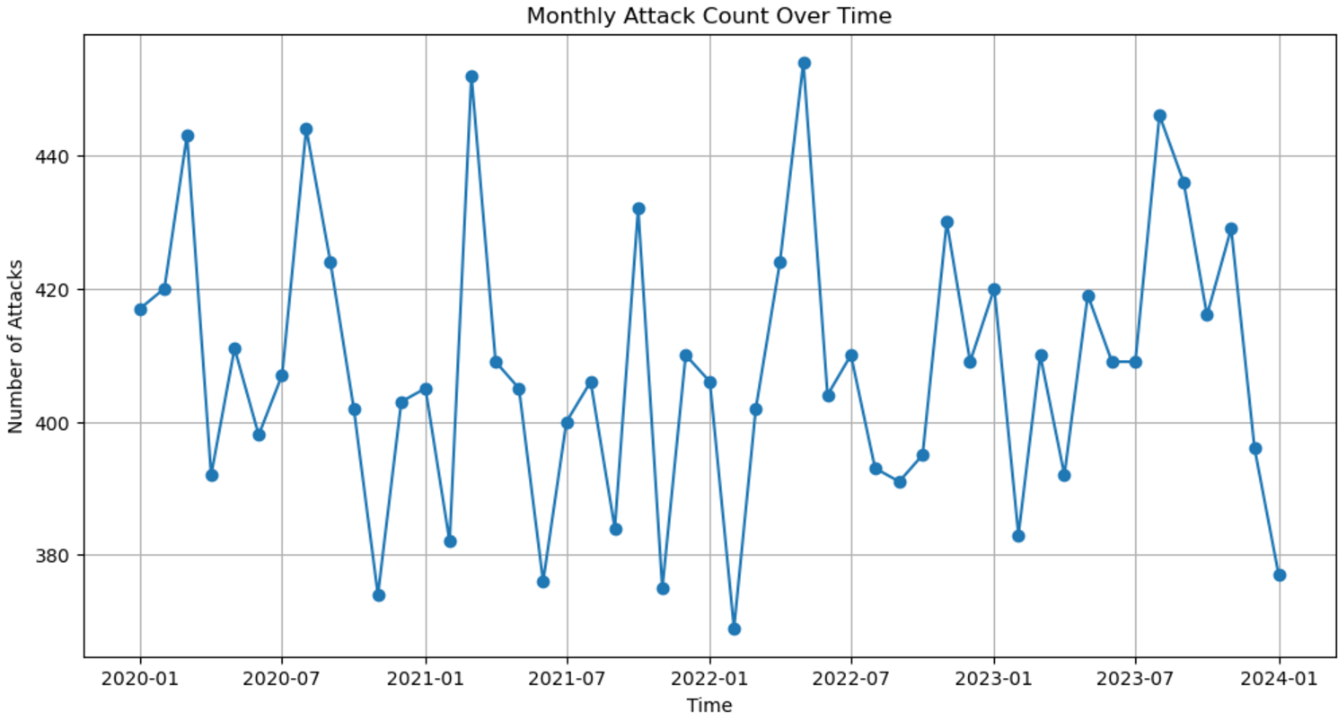
  - From these results, we determined that the trend in the number of attacks was fluctuating, making it very difficult to predict a trend.
6. Conclusions
From our research, we were able to highlight how cybersecurity attacks are complicated to predict. The field of cybersecurity is constantly evolving and new attacks are emerging each day. It is nearly impossible to anticipate what the next attacker will come up with or what type of attack will target a certain infrastructure. The nature of an attack depends on the environment of a company and what vulnerabilities could be infiltrated. How the company handles these attacks also changes depending on each incident response plan. These results emphasize the importance of being proactive in cybersecurity defense and adapting to different strategies when things don’t work.
7. Future Work
For our future work, we would like to further discover the data using the source and destination IP addresses to locate the actual geographical locations of the attacks. In this dataset’s case, each IP address was unique, and taking the time to research each one individually would have been time-consuming. However, we believe that analyzing IP addresses could provide valuable insights into attack patterns and improve the accuracy of our predictions.
8. Acknowledgements and Reflection on the Use of LLMS
For our second KNN model, using the smaller set, we used ChatGPT to generate its own optimal model. Given that our initial belief that our model was not producing optimal results, we wished to compare it with an AI-generated code to determine whether or not it would lead to a significant improvement. This allowed us to determine whether AI could enhance the efficiency of our previous efforts. We also wish to acknowledge Dr. Jia with her assistance in guiding us through and helping make this project a success.
9. References
[1] Hassane, Skikr. “AI-Enhanced Cybersecurity Events Dataset” Kaggle, February 2024, https://www.kaggle.com/datasets/hassaneskikri/ai-enhanced-cybersecurity-events-dataset?resource=download.
[2] https://scikit-learn.org/stable/modules/generated/sklearn.tree.DecisionTreeClassifier.html

